**1. Homepage: Replace the text in two of the call to action buttons with:**

* I’m a Private Consumer
* I’m a Professional Consumer

RFQ-step 1: The same in RFQ step 1

Waht type of consumer are you:

* I’m a Private Consumer
* I’m a Professional Consumer

**2. Homepage: Testemonials**

Remove the ”Freightos” logo in the bottom of the homepage, on the ”consumers testemonials”

* We will input testemonials in this section during the comming week

Preliminary you can have the SeaDex logo and the following text on every ”testemonial” slide:

*Without compromising on any individual rates or individual company identities, SeaDex uses secure and proven technology to connect Freight Forwarders with Consumers of container freight, worldwide*.

**3. About: *Replace the existing text with the text below:***

Without compromising on any individual rates or individual company identities, SeaDex uses secure and proven technology to connect Freight Forwarders with Consumers of container freight, worldwide.

The challenge for the 'Freight Buyer' is that containerized shipping is a very complex industry and the pricing structure is diffucult to understand.

Seadex users will benefit from a transparent view of the pricing, routes, schedules and ship ownership all which are variables and factors for you to evaluate the value proposition.

Seadex matches your requirements either as a 'Freight Buyer' or 'Freight Seller' delivering the best 'Value" for the deal based on your requirements.

Selecting a 'Freight Supplier' is not just picking the cheapest price, the factors that Seadex provides includes key indicators including;

Price

Availability

Transit Time

Transit Route - Direct or Indirect

Quality and Reputation

SeaDex enables:

* RFQ’s only sent to the most competitive Freight Forwarders for the respective route
* Freight Forwarders compete for your shipments
* Significantly decrease time spent on sourcing vendors (ISO 9001)
* Contract Bidding from all Logistic Companies and Freight Forwarders (Launch Q4 – 2014)
* Benefit from other companies price negotiations
* Decrease your Carbon Footprint in LCL shipments (ISO 14001)
* Seadex Market allows reduced cost for LCL cargoes (Launch –Q3 2014)

The SeaDex Team has a various background with expertise in Shipping, Software Development and specifically 'Shipping Software' that solved solutions equally complex for other companies.

*Our goal is to make the world a better place by optimizing the global seaborne freight capacity.*

**4. History: *Replace the existing text with the text below and insert the pictures:***

SeaDex was founded by the six co-founders in 2013. The common ground between the founders was several experiences, both private and professional, dealing with the difficulty and time time consumption in sourcing the optimal service providers when shipping goods in containers, overseas.

Carlos:JBJørnAreÅge

Morten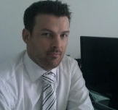RuneAlistair (No picture)

**5. Situation:**

*The follonwing text should be placed* ***under*** *this image 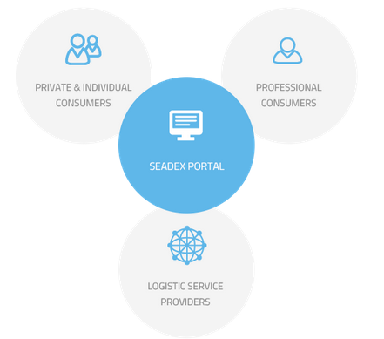*

The Container Market at a Glance:

* Around 95% of the world trade is carried on ships
* Over $150 billion in turnover in 2013
* The container industry grows an average of 4% more than the world economics annually
* Over 17 million containers are shipped over 200 million times per year
* The percentage of empty containers being shipped is over 20%
* Sea freight transport is by far the most environmental friendly way of transporting goods. Sea freight have 3 times less carbon footprint than trailers and 25 times less carbon footprint than plane

*Source: BIMCO, CRSL, WTO (shipping), Clarckson, EU-Commission (Trans Baltic), Aplphaliner, SupplyChainBrain,*